AgroNexa: A Farm Equipment Renting Portal with ML based Recommendation System

1Dr.K. Priyadharshini, 2Ayush Srivastava, 3Hansa Verma

1 Assistant Professor, 2,3 UG Final Year Computer Science and Engineering Students

Department of Computing Technologies

SRM Institute of Science and Technology, Kattankulathur

[priyadhk4@srmist.edu.in](mailto:priyadhk4@srmist.edu.in) , [as6757@srmist.edu.in](mailto:as6757@srmist.edu.in) , [hv2295@srmist.edu.in](mailto:hv2295@srmist.edu.in)

***Abstract*— Agriculture, the backbone of many economies, faces the dual challenges of increasing food production to meet growing global demand while ensuring the sustainability of farming practices. In the context of India, where agriculture is a way of life for millions, the need for innovation in the sector is more critical than ever. The Farm Equipment Rental Portal, known as "AgroNexa," emerges as a transformative solution to address these challenges. AgroNexa is an online platform that bridges the gap between traditional farming practices and cutting-edge technology. It offers an extensive range of farm equipment available for rent, providing farmers with cost-effective and convenient access to machinery that can boost productivity. This portal leverages the power of digital connectivity to connect equipment owners with farmers seeking specific tools for their agricultural tasks. One of AgroNexa’ s distinguishing features is its incorporation of a crop recommendation system.**

***Keywords –* Farmer, Rental, Machine Learning, Website, Portal.**

1. INTRODUCTION

The agricultural sector of India occupies a pivotal role in the country's economy, society, and on the global stage. It holds substantial importance by making a significant contribution to the nation's economic well-being. Furthermore, it employs a considerable portion of the population and plays a vital role in upholding food security. With roughly 58% of the rural labour force involved in agricultural pursuits, this sector contributes approximately 15% to India's Gross Domestic Product (GDP). Despite its critical importance, the agricultural industry in India encounters several urgent challenges, such as existing yield disparities, limited levels of mechanization, and obstacles related to market access. Nevertheless, there are openings to modernize this sector through the adoption of technology, enhanced methods of irrigation, diversification of crops, and more efficient management of the supply chain. Such endeavours have the potential to result in increased productivity, income generation, and bolstered resilience in the face of global uncertainties.

AgroNexa is one step solution to many of these problems, by introducing “Pay as you go” scheme to farm equipment’s and machinery which removes the burden of buying individual equipment’s by small farmers and at the same time helps them earn additional income by renting any spare equipment’s to other farmers.

It uses a Web-based portal and A Recommendation System which takes into account various perimeters like Amount of Nitrogen(N), Amount of Phosphorus(P), Amount of Potassium(K), rainfall (in cm), temperature, humidity and pH level into account to suggest best crop variety to grow for maximum profit and recommends equipment’s related to it for renting.

1. LITERATURE SURVEY
2. The paper titled "Spry Farm: A Portal for Connecting Farmers and End Users" presents the idea of developing a web portal that directly connects farmers and end-users in the agricultural sector. The primary concept is to eliminate the middlemen, allowing farmers to sell their produce directly to customers. The portal employs the Max-Prior algorithm to allocate products to customers with the highest requirements, optimizing the distribution process. This approach benefits both farmers, who can potentially increase their profits, and customers, who gain access to fresh and affordable produce [2].
3. The paper titled "Design and Development of a Persuasive Technology Method to Encourage Smart Farming" by Ramalatha Marimuthu, Alamelu M, Suresh A, and Kanagaraj S discusses the use of persuasive technology to change the mindset of farmers in Tamilnadu, India, towards adopting modern agricultural practices supported by technology. The paper introduces a persuasive technology method (PTM) consisting of a website and mobile app. The website serves as a knowledge base for farmers, providing information on crop cultivation, farming practices, marketing, and agricultural resources, while the app helps farmers access this information. The PTM employs various persuasive methods, such as promotional gifts and awareness campaigns, to increase awareness and usage among farmers, with a focus on the younger generation. The paper aims to improve agricultural productivity, reduce the digital divide, and enhance farmers' access to essential information and technology. The effectiveness of the PTM is tested, and metrics are analyzed to refine the approach [3]
4. The paper "e-SmallFarmer - A Solution for Small Farming" proposes an IoT-based solution to address the challenges faced by small farmers in low-density regions, particularly in Portugal. It introduces an IoT device that allows farmers to input their agricultural products into a web platform, making them available for potential buyers. This approach aims to reduce the technological gap between rural and urban areas, tackle the lack of production flow, address labor shortages, and combat the issue of increasing abandoned land in Portugal. The authors emphasize the significance of this solution, especially during events like the COVID-19 pandemic, where it can provide an alternative sales channel for small farmers, thereby mitigating economic impacts. Additionally, the paper highlights the role of this solution in promoting a circular economy and sustainable agriculture, contributing to rural development and creating a more accessible and efficient marketplace for small-scale producers [5].
5. The paper "Innovation for Crop Quality Certification using ICT" discusses the use of Information and Communication Technology (ICT) to implement Global Good Agriculture Practices (GAP) certification in the Indian agriculture sector, with a focus on orange production in Amravati district, Maharashtra. The paper presents an innovative approach to improving food quality, environmental sustainability, and farmer livelihoods. However, it highlights several challenges, including the initial resistance of farmers to adopt certification due to low awareness and perceived risks, limited mobile connectivity in rural areas, and the high cost of certification. Additionally, the success of the pilot project might not necessarily generalize to other crops and regions. Despite these challenges, the paper demonstrates the potential benefits of using ICT for agricultural certification, and its scalability and long-term impact warrant further exploration and adaptation to address the issues identified [6].
6. The Agro Bidding system is an innovative online auction platform designed to connect farmers and consumers directly, eliminating intermediaries. In this system, sellers post agricultural products for auction, and buyers can bid on these products within a specific time frame. The highest bidder at the end of the auction wins the product. The system promotes transparency and enables users to obtain agricultural products at competitive prices. The key benefit of Agro Bidding is its potential to enhance the livelihood of farmers by offering a fair marketplace to sell their produce. This mobile application-based system offers a user-friendly interface for both buyers and sellers, making it an efficient way to trade agricultural goods. It also reduces the time and effort required in traditional auction processes. In the future, additional features such as chat functionality and direct payment options can be integrated to further improve the user experience [12].
7. The blockchain-based farmer's portal presents a promising solution for agricultural trade by offering increased transparency and security. Its key strengths lie in empowering farmers to directly engage with buyers, potentially fetching fairer prices for their crops. The technology ensures data integrity and security through cryptographic measures, making the information stored on the blockchain tamper-proof. This can help in resolving disputes and building trust within the agricultural ecosystem [12].
8. The paper describes the design and development of an Autonomous Precision Farming System (APFS) that leverages automation and technology for precise soil parameter monitoring and control in agriculture. It offers features like real-time monitoring of soil moisture, pH, atmospheric conditions, and more, with the ability to intelligently control pumps and valves to optimize irrigation and fertilization. The system incorporates wireless data acquisition, touch-screen interface, and the ability to send alerts to farmers via SMS. It also enables remote control of agricultural equipment through mobile phones. While the APFS
9. presents several advantages, including efficient resource utilization and cost-effectiveness, it faces challenges such as implementation in real-world agricultural conditions and the need for further enhancements, like incorporating video capturing and mobile apps for improved user experience [14].
10. The paper presents a data-driven cooperative control strategy for wind farms with the goal of maximizing total power production. It addresses the issue of wake interference, where the power production of downstream wind turbines is negatively impacted by the wake generated by upstream turbines. The authors propose using the Bayesian Ascent (BA) algorithm, a probabilistic optimization method that combines Gaussian Process regression and trust region concepts, to determine optimal coordinated control actions for wind turbines. Wind tunnel experiments with scaled models of wind turbines are conducted to validate this approach [15].
11. EXISTING MODEL

Traditionally, farmers have relied on purchasing their own equipment to carry out various farming activities. However, this practice has both advantages and disadvantages. The emergence of farm equipment rental portals has provided an alternative approach to acquiring the necessary machinery for agricultural operations. In this analysis, we will explore the traditional practice of buying farming equipment, its advantages, and disadvantages in comparison to utilizing a farm equipment rental portal. The advantage of this system is just Ownership and Control. While its Demerits highly outweigh it, those are High Initial Costs, Maintenance Expenses, Depreciation, Limited Usage and Dept traps to buy equipment.

IV. PROPOSED MODEL

The system under consideration provides a contemporary answer to tackle the constraints and issues linked to the conventional approach of procuring farming machinery. This inventive platform harnesses technology to provide farmers with a practical and budget-friendly choice, enabling them to lease the necessary equipment for their farming activities.

Key Features of the Proposed System:

1. Equipment Variety:

The Equipment Rental Portal offers a diverse range of farming machinery, ensuring that farmers have access to the specific tools require for their tasks. From tractors and ploughs to seeders and harvesters, the portal provides a comprehensive selection to cater to various farming needs.

1. Cost-Effective Rental Options:

A key advantage of the suggested system lies in its cost-effectiveness. It enables farmers to lease equipment for particular tasks or seasons without the weight of substantial upfront procurement expenses. This adaptability is especially beneficial for small-scale farmers who might have restricted capital at their disposal.

1. Accessibility and Convenience:

The portal is accessible through the internet, making it easy for farmers to browse equipment options and reserve what they need from the comfort of their homes. This convenience eliminates the need for time-consuming visits to equipment dealers or rental agencies.

1. Maintenance and Support:

The proposed system often includes maintenance and support services provided by the rental provider. This feature relieves farmers of the responsibility of equipment upkeep, ensuring that the machinery is in optimal working condition.

1. Reduced Financial Risk:

By avoiding the significant upfront costs of equipment purchase, farmers can reduce financial risk. This approach also mitigates concerns related to equipment depreciation and resale value.

Benefits of the proposed system:

1. Cost Savings: The foremost advantage of the suggested system is its ability to save costs. Renting equipment diminishes the financial strain on farmers, providing an affordable choice, particularly for those with limited budgets.
2. Access to Specialized Machinery: The system grants access to a wide range of specialized farming equipment, empowering farmers to pick the most appropriate machinery for their specific tasks.
3. Reduced Maintenance Responsibilities: Rental providers typically manage maintenance and repairs, sparing farmers from the time and expenses linked with equipment upkeep.
4. Versatility and Adjustability: The system presents versatility in equipment selection, allowing farmers to accommodate evolving requirements and changing agricultural seasons.
5. WORKING MODULE
6. Web Interface: Utilizing HTML, CSS, JavaScript, and UI components.
7. Web Server: Powered by Node.js.
8. Application Services: Designed to meet business requirements.
9. Machine Learning Recommendation System: Employing algorithms such as Naïve Bayes, Support Vector Machine (SVM), Random Forest, k-Nearest Neighbor, and Boosting.
10. Databases: Utilizing SQLite3, MySQL, and MongoDB.
11. Homepage: This section serves as the website's front page, showcasing website content and providing a brief introduction to its purpose. It also contains links to other pages within the website.
12. Recommendation Page: Here, users can input data such as potassium levels, nitrogen levels, phosphorus levels, rainfall amounts, temperature, and pH details. The page then offers crop variety recommendations for planting and provides links to equipment rental listings related to the chosen plant.
13. Login Page: This page is used for user authentication, allowing users to log in or register for the website. It is a crucial component for implementing the payment system.
14. Listings Page: This section displays available equipment rental listings, offering essential information about each item's age, location, and expected rental rates.
15. Dataset: Access to an open-source dataset for use in designing the recommendation system and other data-related purposes.



1. IMPLEMENTATION

Precision agriculture is currently a prevailing trend, revolutionizing farming practices by providing informed decision-making tools for farmers. Presented here is a dataset that allows users to construct a predictive model for recommending the most suitable crops to cultivate on a particular farm, based on various parameters. This dataset was created by amalgamating data from rainfall, climate, and fertilizer sources available for India.

Data Fields:

• N - Nitrogen content ratio in soil

• P - Phosphorous content ratio in soil

• K - Potassium content ratio in soil

• Temperature - Soil temperature in degrees Celsius

• Humidity - Relative humidity in percentage

• pH - Soil pH value • Rainfall - Rainfall in millimetres

Algorithm Implementations:

* Naïve Bayes
* Support Vector Machine (SVM)
* Random Forest
* K-nearest Neighbor
* AdaBoost

Web Portal Implementation

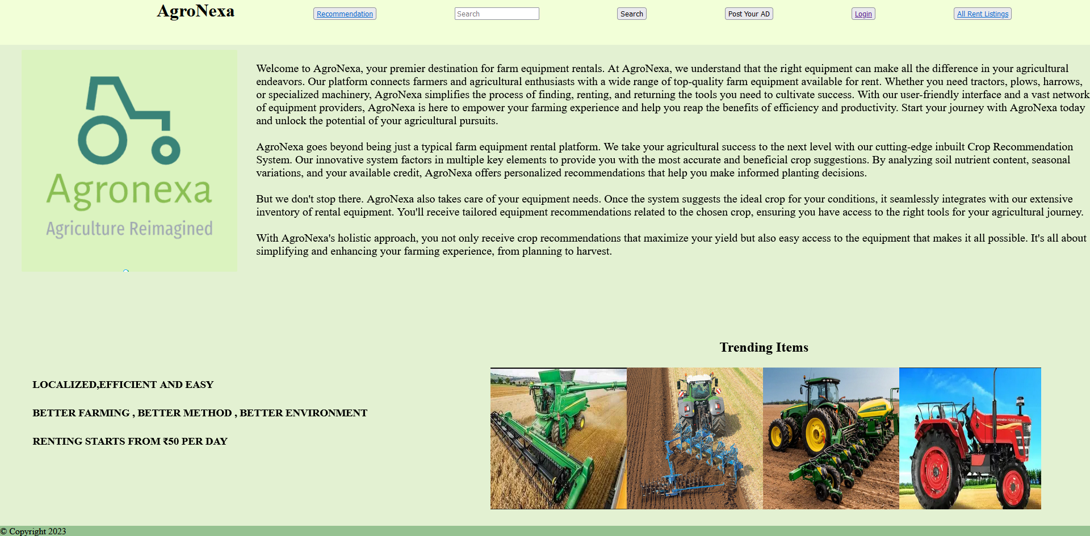

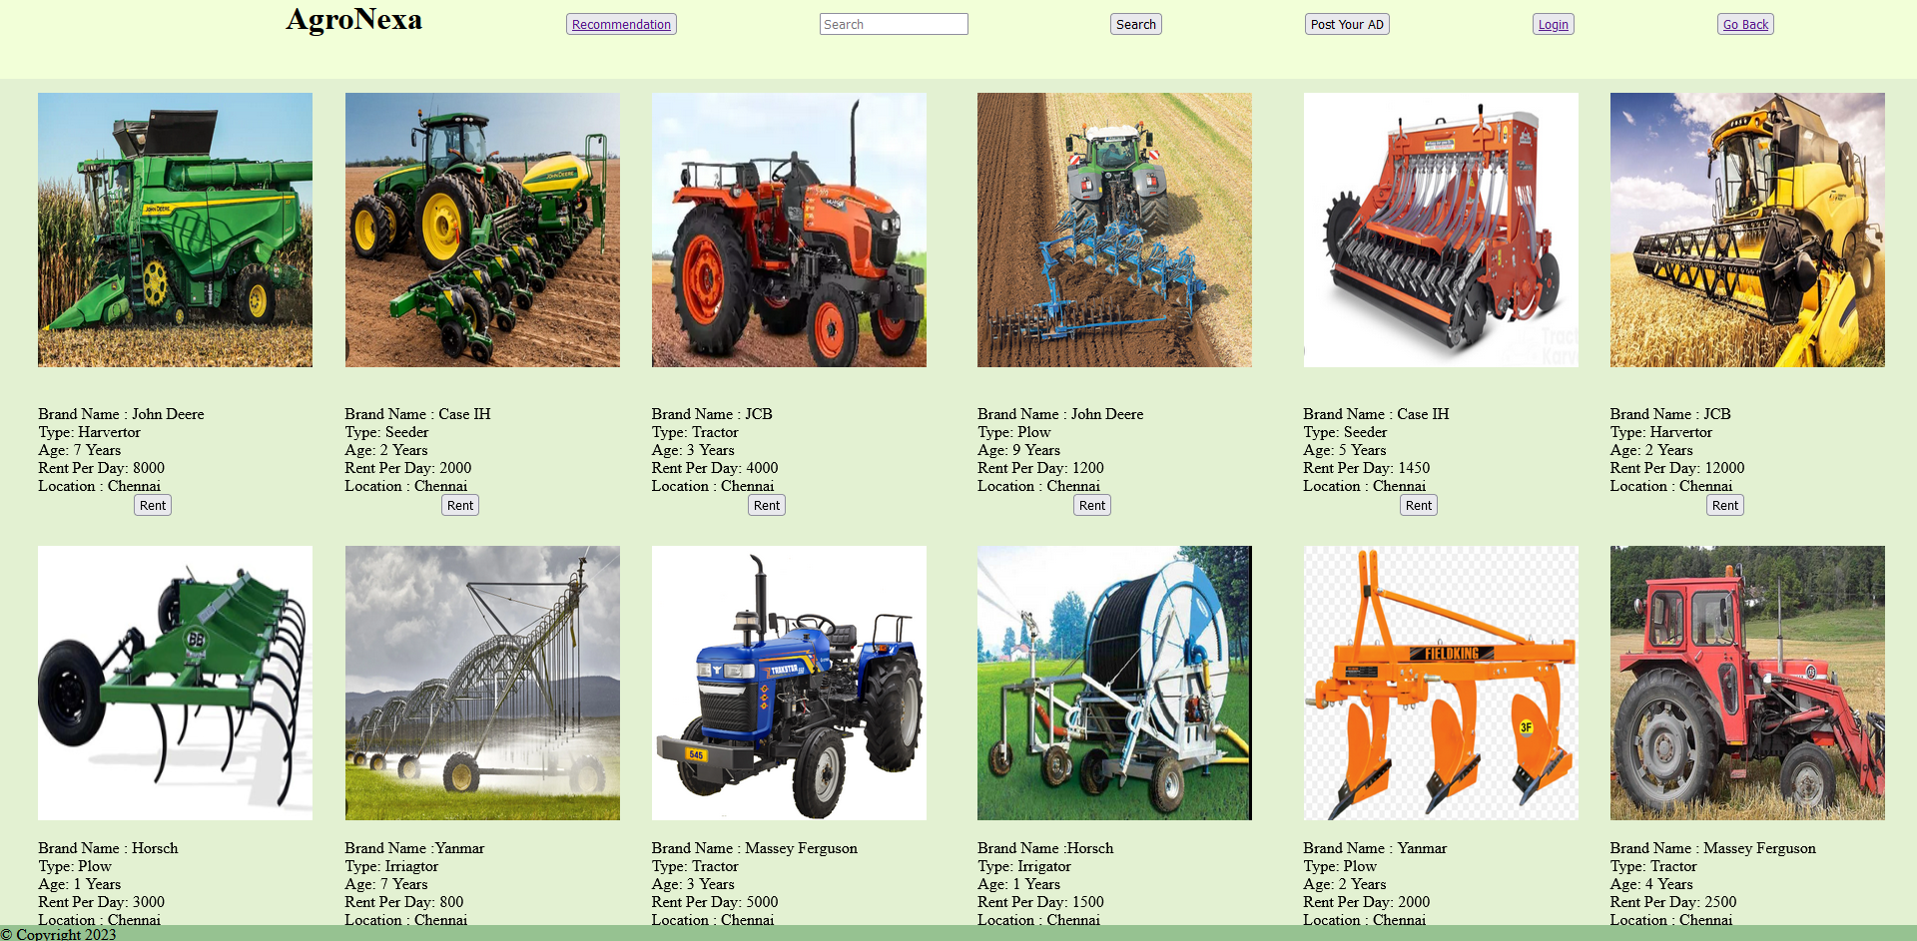

1. RESULTS AND DISCUSSION

Accuracy Results for Machine Learning Algorithms:

* Naïve Bayes: 98.86%
* SVM: 97.73%
* K-nearest Neighbor: 88.18%
* Random Forest: 99.32%
* AdaBoost: 9.55%

Based on the provided accuracy results for various machine learning algorithms, it's evident that Random Forest achieved the highest accuracy at 99.32%, followed by Naïve Bayes with 98.86% accuracy. While these high accuracy scores indicate that both Random Forest and Naïve Bayes are strong candidates for developing a recommendation system, the choice of algorithm should also consider other factors:

Accuracy: Random Forest excels in precision, making it suitable for tasks where accuracy is paramount.

Complexity: Random Forest is more complex and computationally intensive, while Naïve Bayes is simpler and efficient.

Interpretability: Naïve Bayes offers easily interpretable results, whereas Random Forest's ensemble nature can make it less interpretable.

Scalability: Naïve Bayes works well with large datasets, while Random Forest can be resource-intensive with very large datasets.

Robustness: Random Forest is robust in handling noisy or missing data, making it a strong choice for real-world, messy datasets.

Overfitting: Naïve Bayes is less prone to overfitting, while Random Forest requires careful tuning to avoid overfitting.

Algorithmic Requirements: The choice should consider specific system requirements, including real-time prediction, memory usage, and online learning needs.

While Random Forest stands out with the highest accuracy, the choice between Random Forest and Naïve Bayes should weigh these trade-offs. If interpretability and computational efficiency are crucial, Naïve Bayes may be preferable. For the utmost accuracy, Random Forest is the choice.

1. CONCLUSION

Building a Farm Equipment Rental Portal with a Crop Recommendation System In the ever-evolving realm of agriculture, the integration of modern technology is imperative for the sustainability and prosperity of the farming community. Our journey in creating a Farm Equipment Rental Portal with a Crop Recommendation System underscores the potential of innovation in meeting the evolving needs of farmers and agricultural stakeholders.

Throughout this project, we have achieved significant milestones, emphasizing the following key points:

Empowering Farmers: Our Farm Equipment Rental Portal's core objective is to empower farmers by providing them with a user-friendly platform for accessing and renting a wide range of farm equipment. By eliminating the barriers associated with equipment ownership, we make modern, efficient farming practices accessible to all, regardless of farm size or location.

Crop Recommendation System: The integrated Crop Recommendation System leverages data-driven insights to assist farmers in making informed decisions about crop cultivation. By considering various factors such as soil conditions, climate, and market demand, we enable farmers to optimize their crop selection, resulting in increased yields and profitability.

Enhancing Efficiency: Our platform aims to boost the efficiency of agricultural operations. By recommending equipment tailored to the chosen crop, we ensure that farmers have access to the tools best suited to their specific needs, reducing waste and enhancing productivity.

Sustainability and Environmental Responsibility: Our platform underscores our commitment to sustainability and environmental responsibility. By helping farmers optimize crop selection and equipment use, we contribute to more sustainable farming practices, reducing resource wastage and environmental impact.

Machine Learning and Data Analysis: The incorporation of machine learning techniques for crop recommendation and data analysis for equipment selection has been a pivotal component of our project's success, bringing data-driven decision-making to the forefront of agriculture.

REFERENCES

[1] P. Saindane, S. Bugtani, Y. Hiranandani, V. Jagtap and K. Rajpal, "SwasthPhasal: An Efarming

Web Portal," 2022 Second International Conference on Advanced Technologies in

Intelligent Control, Environment, Computing & Communication Engineering (ICATIECE),

Bangalore, India, 2022, pp. 1-5,

[2] R. Sneha Iyer, R. Shruthi, K. Shruthhi and R. Madhumathi, "Spry Farm: A Portal for

Connecting Farmers and End Users," 2021 7th International Conference on Advanced

Computing and Communication Systems (ICACCS), Coimbatore, India, 2021, pp. 429-433,

[3] R. Marimuthu, M. Alamelu, A. Suresh and S. Kanagaraj, "Design and development of a

persuasive technology method to encourage smart farming," 2017 IEEE Region 10

Humanitarian Technology Conference (R10-HTC), Dhaka, Bangladesh, 2017, pp. 165-169,

[4] M. Kumari, V. Kumar and V. Agarwal, "Multidisciplinary Real-Time Model for Krishi

Seva," 2021 5th International Conference on Information Systems and Computer Networks

(ISCON), Mathura, India, 2021, pp. 1-4

[5] D. Pinto, R. Alves, P. Matos and D. Pousa, "e-SmallFarmer - A solution for small

farming," 2020 IEEE International Workshop on Metrology for Agriculture and Forestry

(MetroAgriFor), Trento, Italy, 2020, pp. 104-108

[6] D. Singh, A. Pande, S. Kulkarni, S. Kimbahune, T. Hanwate and A. Sawarkar,

"Innovation for crop quality certification using ICT," 2015 7th International Conference on

Communication Systems and Networks (COMSNETS), Bangalore, India, 2015, pp. 1-6,

[7] S. S, S. S R, V. L R and M. R, "Agro World: A Naive Bayes based System for Providing

Agriculture as a Service," 2022 6th International Conference on Intelligent Computing and

Control Systems (ICICCS), Madurai, India, 2022, pp. 1871-1875

[8] M. Jadhav, N. Kolambe, S. Jain and S. Chaudhari, "Farming Made Easy using Machine

Learning," 2021 2nd International Conference for Emerging Technology (INCET), Belagavi,

India, 2021, pp. 1-5,

[9] N. G., S. R., S. K. and S. D. N. S., "Agro Bidding - A Smart Dynamic System for

Enhancement of Farmer's Lifestyle," 2019 International Conference on Smart Structures and

Systems (ICSSS), Chennai, India, 2019, pp. 1-4

[10] V. Lešić et al., "Rapid Plant Development Modelling System for Predictive Agriculture

Based on Artificial Intelligence," 2021 16th International Conference on Telecommunications

(ConTEL), Zagreb, Croatia, 2021,

[11] N. Krishnan, R. Surendran and M. Nathan, "Crop tracker - A web application to sell or

buy crops and predict crop price using machine learning," 6th Smart Cities Symposium (SCS

2022), Hybrid Conference, Bahrain, 2022, pp. 152-156

[12] R. Talreja, R. Chouksey and S. Verma, "A Study of Blockchain Technology in Farmer's

Portal," 2020 Second International Conference on Inventive Research in Computing

Applications (ICIRCA), Coimbatore, India, 2020, pp. 828-833,

[13] G. Egger, P. Sacco, D. Chaltsev and F. Mazzetto, "farMAS: Multi-Agent based farm

activity planning and execution system," 2021 IEEE International Workshop on Metrology

for Agriculture and Forestry (MetroAgriFor), Trento-Bolzano, Italy, 2021, pp. 411-415

[14] U. S. Rajani, A. Sathyan, A. Mohan and A. A. Kadar, "Design architecture of

autonomous precision farming system," 2017 International Conference on Intelligent

Computing, Instrumentation and Control Technologies (ICICICT), Kerala, India, 2017, pp.

415-419,

[15] J. Park, Soon-Duck Kwon and K. H. Law, "A data-driven approach for cooperative wind

farm control," 2016 American Control Conference (ACC), Boston, MA, USA, 2016, pp. 525-530,